COMPARISON SHEET-

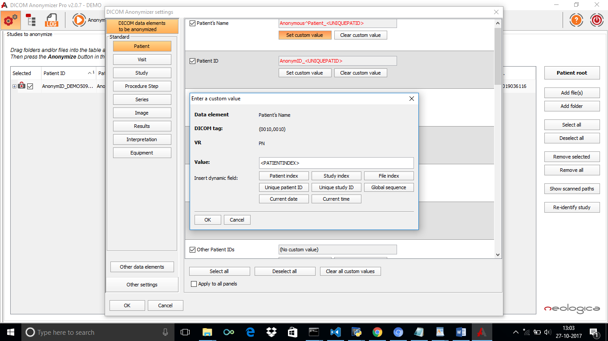

**SOFTWARE**   **PYDICOM LIBRARY**

* Allows various options for Anonymized value Currently allows a single Data Inserting Dynamic fields like Patient Index, element value to be ‘XXXX’ or same StudyIndex, fileIndex etc as the ‘file name’.

As shown in the figure.

* Allows multiple data elements to Allows a single data element to be

be anonymized anonymized.

* Allows user to choose any file Allows to anonymized data element of

From the system files in the path inside code.

* The log shows the data elements value after No logs available. To view the data

Anonymization. Elements value run the command

ds=read_file(“path”,’br’)

ds.dir.